Assignment 3.2
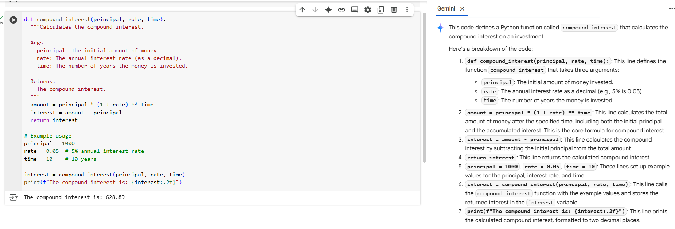
TASK 1: write a function to calculate compound interest, starting with only the function name
- TASK 2: Write a function to calculate average, median, and mode of a list of numbers.
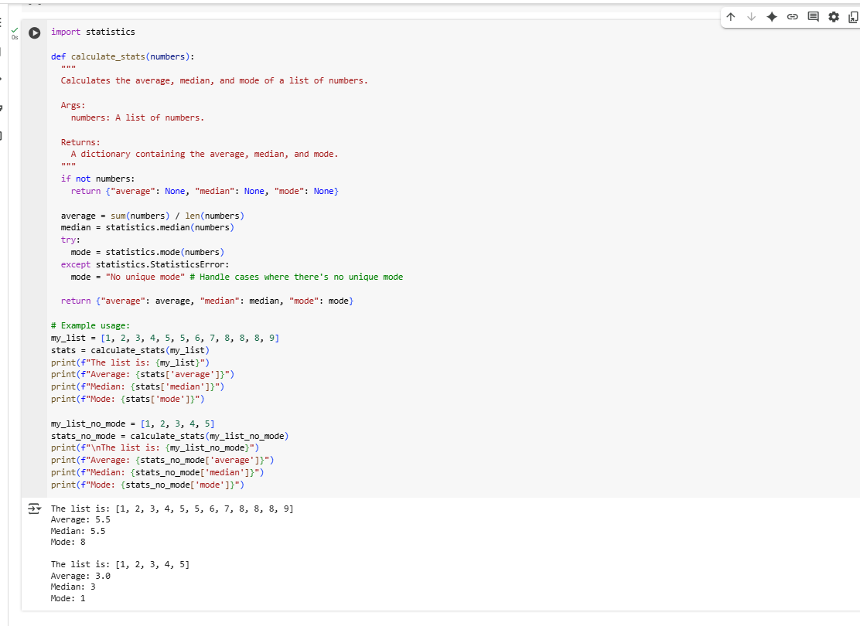
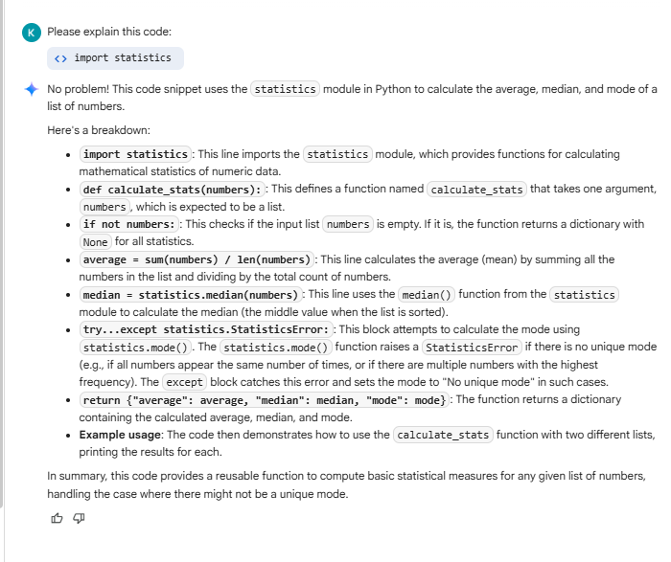
TASK 3: Provide multiple examples of input-output to the AI for convert_to_binary(num) function
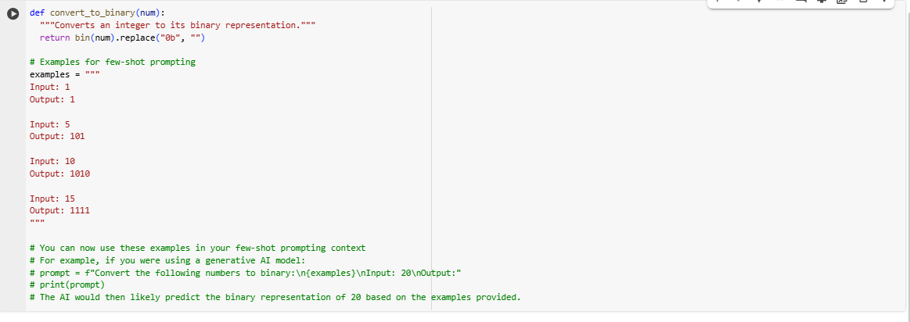
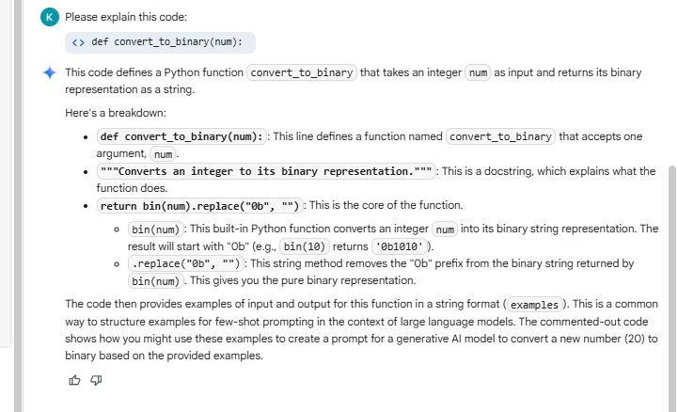
- TASK 4: Create an user interface for an hotel to generate bill based on customer requirements
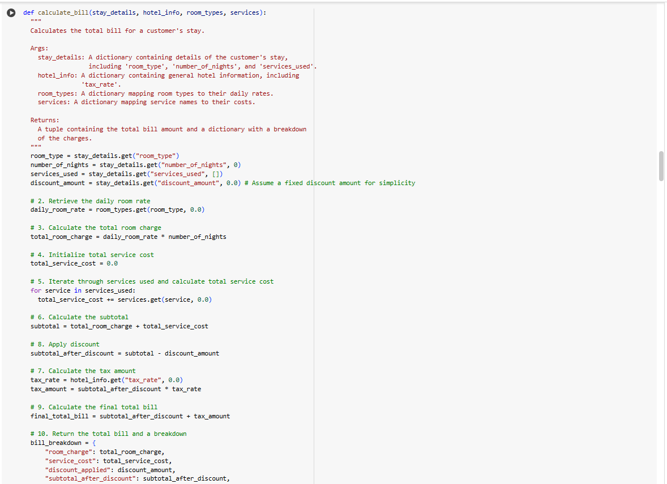
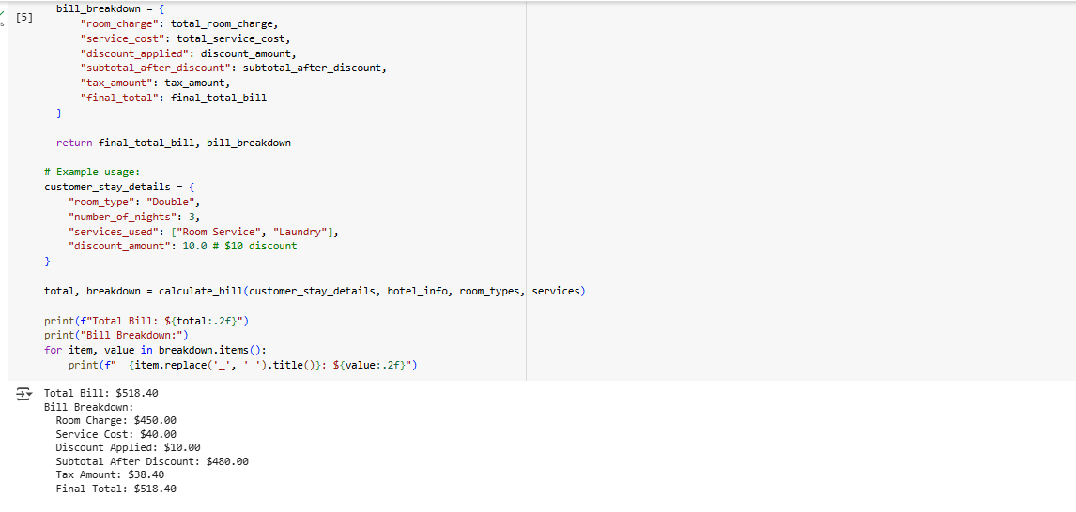
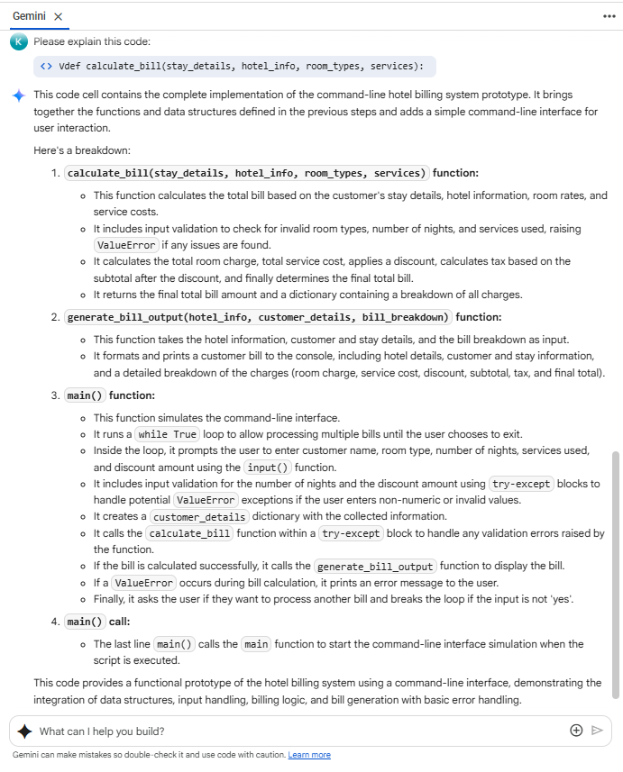

- TASK 5 : Improving Temperature Conversion Function with Clear Instructions
